Test result for task008

T008.1: Verify that pdfbox provides a mechanism for highlighting texts

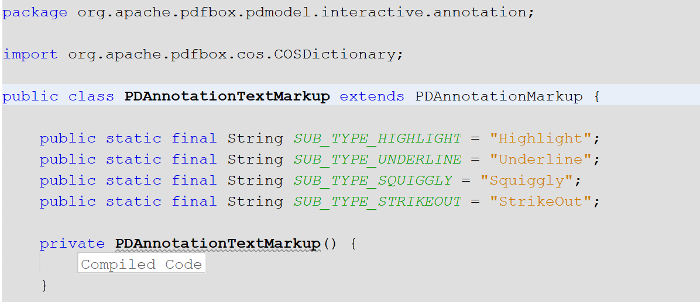

T008.2: Identify a method for a user to highlight texts

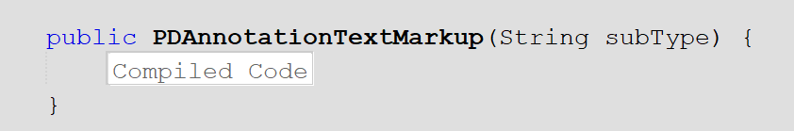

T008.3: Demonstrate user highlighting texts

